# 

# 

# 

Motus-DCS Integration Guide

Version 0.1

NOAA/NOS/CO-OPS: David Ilogho & Nathan Holcomb

NOAA/NESDIS: Daniel Gillies

# 1.0 Concept of Operations / System Architecture

## Daniel will write & add overview diagram (bird to DADDS) showing how the system as a whole works and what the major components are

# 2.0 Motus-DCS Diagramatic illustration



**Figure 1:** Motus-DCS Hardware Schematic

# 

# 3.0 Motus-DCS Data Flow Concept of Operations: Key Steps

This outline describes the steps in the Motus-DCS data flow from the initial transmission by wildlife tags to the message relayed via the DCS satellite.

* A bird tag transmits Tag ID.
* The Motus receiver (SensorGnome) detects the tag ID using the antenna and records the antenna port, unix time, tag ID and Signal strength RSSI. This information is both stored on the SensorGnome receiver and echoed to the serial port. Tag ID Example: **T4,1724091984.774, 78554c3358, -75.**
* The echoed tag is received by the interface board (IB), and stored on a microSD card with the file path ‘SD/RCVDMSGS/YYMMDD/MSGSx’. Here, YY, MM and DD represent the two-digit year, month, and day, while `x` is an integer that indicates the file sequence for that day, starting at 0 with each reboot. For example, if the latest file is ‘SD/RCVDMSGS/241231/MSGS0’ and the IB is rebooted, a new file ‘SD/RCVDMSGS/241231/MSGS1’ will be created. As more tags are received, the IB keeps updating the same file.
* Three minutes before the DCS transmitter’s scheduled transmission time, the IB retrieves a chunk of unsent messages from its microsD card, appends the DCS transmitter’s battery voltage and transmission status message that will fit into the transmission window if there are more unsent messages than the window can accommodate, otherwise all the unsent messages are retrieved. A position tracker records the location of the last sent message in the file.
* The retrieved messages are sent via serial to the DCS transmitter’s buffer for transmission. The DCS transmitter then responds indicating whether the messages were successfully received or not.
* The IB then stores the message, DCS transmitter’s response, and the timestamp on the microSD card at the file path ‘SD/TXARCH/YYMMDD/SENT.TXT’ if the transmitter receives the message, otherwise it saves it in ‘SD/TXARCH/YYMMDD/UNST.TXT. This does not indicate if the message was successfully transmitted or not, it only indicates if the message was successfully sent to the DCS transmitter.
* The interface board then sends the status message without the DCS transmitter’s battery voltage to the SensorGnome. The status message is as follows.
  + Appx maximum number of bytes per interval. This is based on the Baud rate and transmission window and does not change.
  + Remaining bytes to be sent. This will be zero if there are no pending bytes in the SD card yet to be transmitted.
  + No of bytes that can be accepted for the next transmission window. This will be zero if the number of bytes yet to be transmitted is equal to or greater than the maximum number of bytes that can be transmitted.
  + Days before remaining bytes can be completely sent.
  + Hours before remaining bytes can be completely sent
  + Minutes before remaining bytes can be completely sent

Example message: 970,0,970,0,0,6.

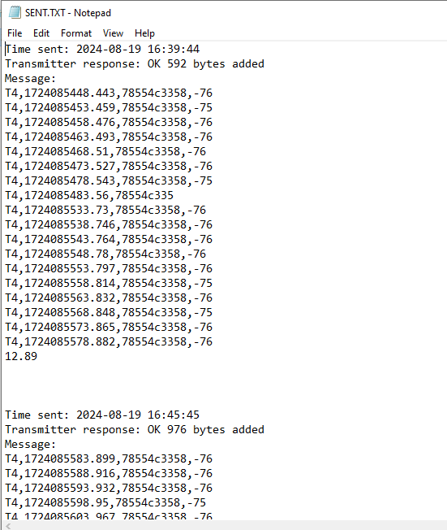

**Figure 2:** Sample message with DCS Transmitter’s response

* Approximately three minutes later, at the time of transmission, the DCS transmitter grabs the data in its buffer and transmits the data via GOES.

# 4.0 Parts List

To get started, you will need the following items to set up the system.

## 4.1 SensorGnome Assembly Parts List

* This contains all the required components for the SensorGnome configuration used in this build guide. The instructions for setting up the SensorGnome are provided at the link in the Note..
* For this build we are using a single SensorGnome board with a single “CTT Dongle” (see notes for build instructions). See the end of this guide for how to include additional CTT Dongles or how to add the Lotek SDR receiver..etc..
* For future development, the SensorGnome Assembly may be replaced with alternate Motus receivers should they be available.

**Table 1**

| index | Name | Image | Part Number | Available Source(s) | Approximate Cost | Notes |
| --- | --- | --- | --- | --- | --- | --- |
| a1 | Raspberry Pi 4 B 8GB |  | SC0195(9) | [SC0195(9) Raspberry Pi | Embedded Computers | DigiKey](https://www.digikey.com/en/products/detail/raspberry-pi/SC0195-9/12159401) | $75.00 | Click [here](https://docs.motus.org/sensorgnome) for more information. |
| a2 | SD/MicroSD Memory Card - 16GB Class 10 - Adapter Included |  | 2693 | [SD/MicroSD Memory Card - 16GB Class 10 - Adapter Included : ID 2693 : Adafruit Industries, Unique & fun DIY electronics and kits](https://www.adafruit.com/product/2693) | $19.95 | The microSD card fits into the Raspberry Pi. The SD card adapter provides an option to connect to a PC for Sensorgnome configuration. |
| a3 | 3 Feet USB-A to USB-C Cable |  | 2057-CA-USB-AM-CM-3FT-ND | [CA-USB-AM-CM-3FT Adam Tech | Cable Assemblies | DigiKey](https://www.digikey.com/en/products/detail/adam-tech/CA-USB-AM-CM-3FT/9830211?utm_adgroup=&utm_source=google&utm_medium=cpc&utm_campaign=PMax%20Shopping_Product_High%20ROAS%20Categories&utm_term=&utm_content=&utm_id=go_cmp-20222717502_adg-_ad-__dev-c_ext-_prd-9830211_sig-Cj0KCQjwgrO4BhC2ARIsAKQ7zUmZTVX4sUUzG08IlLLRk0SF3kfvRnzNxcmYCPB58REvBmbr-Kn7u2UaAuN7EALw_wcB&gad_source=1&gclid=Cj0KCQjwgrO4BhC2ARIsAKQ7zUmZTVX4sUUzG08IlLLRk0SF3kfvRnzNxcmYCPB58REvBmbr-Kn7u2UaAuN7EALw_wcB) | $4.20 | For connecting the Raspberry Pi 4 to power |

### 4.1.1 CTT Dongle Assembly Parts List

**Table 2**

| Index | Name | Image | Part Number | Available Source(s) | Approximate Cost | Notes |
| --- | --- | --- | --- | --- | --- | --- |
| b1 | Adafruit Feather 32u4 with RFM69HCW Packet Radio - 433MHz - RadioFruit |  | 3077 | [Adafruit Feather 32u4 with RFM69HCW Packet Radio - 433MHz [RadioFruit] : ID 3077 : Adafruit Industries, Unique & fun DIY electronics and kits](https://www.adafruit.com/product/3077) | $24.95 | This packet Radio captures and processes UHF signals from CTT tags. |
| b2 | Antenna 433MHz 5dBi OmniDirectional Fiberglass w/ N male. VHF UHF / Marine |  | A433OS | [Antenna 433MHz 5dBi OmniDirectional Fiberglass w/ N male * Marine (data-alliance.net)](https://www.data-alliance.net/antenna-433mhz-5dbi-omnidirectional-fiberglass-w-n-male-vhf-uhf-marine/) | $32.99 | The connection of this antenna to the Adafruit Feather 32u4 enables the omni-directional UHF signal reception of CTT tag transmissions through the RFM69HCW packet radio. |
| b3 | uFL SMT Antenna Connector x 5 |  | 1661 | [uFL SMT Antenna Connector : ID 1661 : Adafruit Industries, Unique & fun DIY electronics and kits](https://www.adafruit.com/product/1661) | $3.75 | The uFL SMT connector is soldered to the Adafruit board, allowing connection to the SMA to uFL/u.FL/IPX/IPEX RF adapter cable. |
| b4 | SMA to uFL/u.FL/IPX/IPEX RF Adapter Cable |  | 851 | [SMA to uFL/u.FL/IPX/IPEX RF Adapter Cable : ID 851 : Adafruit Industries, Unique & fun DIY electronics and kits](https://www.adafruit.com/product/851) | $3.95 | This cable connects the Adafruit Feather to the N Male to SMA Male Cable. |
| b5 | Low Loss N Male to SMA Male Cable Assembly using CA-240 Coax, 20 FT |  | CC-NMSMT020 | [Low Loss N Male to SMA Male Cable Assembly using CA-240 Coax, 20 FT (l-com.com)](https://www.l-com.com/n-male-sma-male-cable-assembly-cc-nmsmt020) | $53.00 | The Adafruit Feather Cable |
| b6 | Coaxial Adapter, Type N-Female / Female |  | AXA-NFNF | [Coaxial Adapter - Type N Female / Female - AXA-NFNF (l-com.com)](https://www.l-com.com/coaxial-coaxial-adapter-type-n-female-female) | $9.85 | This adapter is required to connect the Adafruit Feather cable and the Antenna. |
| b7 | 10" USB-A M/Micro-USB M Cable |  | 5600-FE-USB-ACB5-10IN-ND | [FE-USB-ACB5-10IN My Cable Mart | Cable Assemblies | DigiKey Marketplace](https://www.digikey.com/en/products/detail/my-cable-mart/FE-USB-ACB5-10IN/24373295) | $2.82 | This cable is used to connect the Adafruit Feather to the Raspberry Pi 4. |

## 4.2 Interface Board Assembly Parts List

* This contains all the required components to connect the SensorGnome to a DCS transmitter. This includes Interface board, communications interfaces, jumpers, SD card storage, and auxiliary modules.

**Table 3**

| Index | Name | Image | Part Number | Available Source(s) | Approximate Cost | Notes |
| --- | --- | --- | --- | --- | --- | --- |
| c1 | Arduino GIGA R1 WiFi |  | ABX00063 | [Arduino GIGA R1 WiFi — Arduino Online Shop](https://store-usa.arduino.cc/products/giga-r1-wifi?gad_source=1&gclid=Cj0KCQjwgrO4BhC2ARIsAKQ7zUlN0pK1cLBwEWZ6Y2WBhfXUf1QwgxEEPPRAOJEscV7oluynMvidr1MaArCsEALw_wcB) | $72.82 | Giga is required due to processing speed. |
| c2 | Arduino GIGA Display shield |  | ASX00039 | [Arduino® GIGA Display Shield — Arduino Online Shop](https://store-usa.arduino.cc/products/giga-display-shield) | $63.60 | For displaying the status of the Giga. |
| c3 | Adafruit Ultimate GPS Logger Shield |  | 1272 | [Adafruit Ultimate GPS Logger Shield - Includes GPS Module : ID 1272 : Adafruit Industries, Unique & fun DIY electronics and kits](https://www.adafruit.com/product/1272) | $29.95 | Houses the microSD card for data logging and provides backup GPS synchronization. |
| c4 | SD/MicroSD Memory Card - 16GB Class 10 - Adapter Included |  | 2693 | [SD/MicroSD Memory Card - 16GB Class 10 - Adapter Included : ID 2693 : Adafruit Industries, Unique & fun DIY electronics and kits](https://www.adafruit.com/product/2693) | $19.95 | The microSD card fits into the GPS Logger Shield, with an SD card adapter providing an option to connect to a PC for uploading configuration files. |
| c5 | Sparkfun RS232 to TTL Converter |  | PRT-00449 | [PRT-00449 SparkFun Electronics | Development Boards, Kits, Programmers | DigiKey](https://www.digikey.com/en/products/detail/sparkfun-electronics/PRT-00449/5762433?so=86646617&content=productdetail_US&mkt_tok=MDI4LVNYSy01MDcAAAGS2Fvn7QBQ4MjFVuOXZ5RoW2Sn0pJnMpYbNsRFiX3zNIHky9tP1LtboQRfDv4JNzNA4WIfvOgPQqNVXImJ42QuX8AD-4_sJg5ubNX5szXS) | $17.50 | To convert the DCS transmitter’s RS232 signals to the GIGA’s TTL (Transistor-Transistor Logic) levels and vice versa. |
| c6 | DB9 Male Connector x 2 |  | DGB9MT1 | [DB9 Male Connector for Field Termination - DGB9MT1 (l-com.com)](https://www.l-com.com/d-sub-db9-male-connector-for-field-termination) | $25.98 | For easy serial connection between the RS232 to TTL Converter and DCS transmitter without soldering. |
| c7 | Stackable Header Pins x 3 |  | PRT-16279 | [PRT-16279 SparkFun Electronics | Development Boards, Kits, Programmers | DigiKey](https://www.digikey.com/en/products/detail/sparkfun-electronics/PRT-16279/12178440?utm_adgroup=&utm_source=google&utm_medium=cpc&utm_campaign=PMax%20Shopping_Product_Low%20ROAS%20Categories&utm_term=&utm_content=&utm_id=go_cmp-20243063506_adg-_ad-__dev-c_ext-_prd-12178440_sig-Cj0KCQjwir2xBhC_ARIsAMTXk85NdO4H3v7q_Dt79_HAm5sGkCA3iw9JPd0cvZkuc-lCq2auw6ab_9gaAnpHEALw_wcB&gad_source=1&gclid=Cj0KCQjwir2xBhC_ARIsAMTXk85NdO4H3v7q_Dt79_HAm5sGkCA3iw9JPd0cvZkuc-lCq2auw6ab_9gaAnpHEALw_wcB) | $5.25 | These pins are soldered to the GPS Logger Shield, enabling it to be securely stacked on the Arduino GIGA while keeping the Arduino’s pins accessible for additional shields or components. |
| c8 | 2 x 3 Female Header Pins for SPI connection. |  |  | [Amazon.com: 2 x 3 Female Header Pins](https://www.amazon.com/Connectors-Pro-2-54mm-PCB-Through-Board/dp/B08R8LGM4L/ref=sr_1_9?crid=38EAN3EJVDYD1&dib=eyJ2IjoiMSJ9.CfVMTdzNDCiQZioNzadTjm7n1vpPatd8sBB81VAA_hu_rri_5tR-SWO0v100suIlC3700svCGfqsa1R-gf5xK6shRPPpKLkr3jJGk9NHoEPMvrBfRYHkSOxQ0PIQsm22IVE8x6Ej_KRB3A-q95mmA-63dG7fjqwfgmNdfq4P_aOP02MRguEeUgaF0z0HZI27_PaDDzgRKR6tTsRbP6vICfrRRtPK7D580IskJhD5sk4.MnJpAHAOS7USIOc2dfZ6jdHLSfgn1Ewi4KGvyD3Ked4&dib_tag=se&keywords=2%2Bby%2B3%2Bheader%2Bpins%2Barduino%2Bspi&qid=1728926852&sprefix=2%2Bby%2B3%2Bheader%2Bpins%2Barduino%2Bspi%2Caps%2C82&sr=8-9&th=1) | $6.98 | These pins are soldered to the GPS Logger Shield to connect with the Arduino GIGA’s SPI pins, enabling microSD functionality. Alternatively, you can use stackable header pins cut to size for a similar connection. |
| c9 | 40 Colored Female-Female Jumper Wires |  | TPX00158 | [40 colored female-female jumper wires — Arduino Online Shop](https://store-usa.arduino.cc/products/40-colored-female-female-jumper-wires?queryID=undefined) | $3.50 | For wiring the Arduino GIGA to the SensorGnome and DCS Transmitter |
| c10 | 40 Colored Male-Male Jumper Wires |  | TPX00160 | [40 colored male-male jumper wires — Arduino Online Shop](https://store-usa.arduino.cc/products/40-colored-male-male-jumper-wires?queryID=undefined) | $3.50 | For wiring the Arduino GIGA to the SensorGnome and DCS Transmitter |
| c11 | 40 Colored Male-Female Jumper Wires |  | TPX00159 | [40 colored male-female jumper wires — Arduino Online Shop](https://store-usa.arduino.cc/products/40-colored-male-female-jumper-wires?queryID=undefined) | $3.50 | For wiring the Arduino GIGA to the SensorGnome and DCS Transmitter |
| c12 | 3 Feet USB-A to USB-C Cable |  | 2057-CA-USB-AM-CM-3FT-ND | [CA-USB-AM-CM-3FT Adam Tech | Cable Assemblies | DigiKey](https://www.digikey.com/en/products/detail/adam-tech/CA-USB-AM-CM-3FT/9830211?utm_adgroup=&utm_source=google&utm_medium=cpc&utm_campaign=PMax%20Shopping_Product_High%20ROAS%20Categories&utm_term=&utm_content=&utm_id=go_cmp-20222717502_adg-_ad-__dev-c_ext-_prd-9830211_sig-Cj0KCQjwgrO4BhC2ARIsAKQ7zUmZTVX4sUUzG08IlLLRk0SF3kfvRnzNxcmYCPB58REvBmbr-Kn7u2UaAuN7EALw_wcB&gad_source=1&gclid=Cj0KCQjwgrO4BhC2ARIsAKQ7zUmZTVX4sUUzG08IlLLRk0SF3kfvRnzNxcmYCPB58REvBmbr-Kn7u2UaAuN7EALw_wcB) | $4.20 | To program and power the Arduino GIGA, connect only the USB-C end of the cable to the GIGA’s USB-C port. |

## 4.3 DCS Assembly Parts List

**Table 4**

| Index | Name | Image | Part Number | Available Source(s) | Approximate Cost | Notes |
| --- | --- | --- | --- | --- | --- | --- |
| d1 | DCS Transmitter (Satlink 3 Transmitter used) |  | SL3-XMTR-1 | [SUTRON SatLink 3 SL3-XMTR | OTT HydroMet](https://www.otthydromet.com/en/p-sutron-satlink-3-sl3-xmtr/SL3-XMTR-1) | $2,904.00 (GSA Cost Schedule) | For now, works with Satlink 3 transmitters and Microcom GTX 2.0 |
| d2 | GPS Antenna |  | 3155-ATGGB4336M-SMA-3-ND | [ATGGB4336M-SMA-3 YIC | RF and Wireless | DigiKey](https://www.digikey.com/en/products/detail/yic/ATGGB4336M-SMA-3/18717347?s=N4IgTCBcDaIMwEYCsSC0BBAKgcWwIQBY44A2AWVQGUz1U5UA5AERAF0BfIA) | $9.04 | Most Commercial DCS Transmitters come with a GPS Patch Antenna and separate purchase may not be necessary. |
| d3 | EON2 GOES/Meteosat Antenna with Mount |  |  | [EON2 GOES/Meteosat Antenna - FTS Inc.](https://ftsinc.com/product/eon2-goes-meteosat-antenna/) | $600.00  (GSA Schedule Cost) | DCS transmitter’s antenna |
| d4 | N-Male to N-Male 200 Series Assembly 20.0 ft |  | CA-NMNME020 | [N-Male to N-Male 200 Series Assembly 20.0 ft - CA-NMNME020 (l-com.com)](https://www.l-com.com/coaxial-n-male-to-n-male-200-series-assembly-200-ft) | $51.99 | DCS Transmitter Cable - connects antenna to transmitter |

## 4.4 Power Assembly Parts List

**Table 5**

| Index | Name | Image | Part Number | Available Source(s) | Approximate Cost | Notes |
| --- | --- | --- | --- | --- | --- | --- |
| e1 | Victron Energy BlueSolar PWM-LCD USB 12/24V-5A |  | SCC010005050 | [Victron Energy BlueSolar PWM-LCD&USB 12/24V-5A (solartown.com)](https://solartown.com/solar-products/charge-controllers/victron-energy-bluesolar-pwm-lcd-usb-12-24v-5a/) | $24.65 | This regulates solar power to charge the battery while supplying stable power to the Raspberry Pi 4 and Arduino GIGA via USB, and directly powering the DCS transmitter. |
| e2 | 40 W Solar Panel with Mount |  | 40J-V 2021 | [Ameresco Solar 40J-V 2021](https://www.amerescosolar.com/40j-ameresco-solar-40-watt-solar-panel) | $150.00 | Supplies power to the voltage regulator and ultimately the Motus system and DCS transmitter. |
| e3 | Battery Lead Acid 12V 18AH |  | 3164-PS-12180NB2-ND | [PS-12180 NB2 Power Sonic Corporation | Battery Products | DigiKey](https://www.digikey.com/en/products/detail/power-sonic-corporation/PS-12180-NB2/13577464?s=N4IgTCBcDaIMwEYBsAWAtABQMpoWBAHAAwByAQmGiQCIgC6AvkA) | $66.88 | This keeps the system running at night when there is no Sunlight. |

# 5.0 Software Setup and Configuration

This section provides step-by-step guidance on configuring the software environment for the modules used in this project. Proper setup ensures seamless communication and functionality across components. Additionally, links to relevant resources and sites where prior developments have been made are included.

## 5.1 Adafruit Feather 32u4 with RFM69HCW Packet Radio - 433MHz - RadioFruit

Follow instructions on [Setting up CTT Motus receiver](https://docs.motus.org/sensorgnome/appendix/ctt-dongle) to configure the module. This includes soldering the uFL SMT Antenna connector to the board. A USB-A to Micro USB Cable will be used to connect this module to the Raspberry pi 4.

## 5.2 Raspberry Pi 4 B 8GB

Follow instructions on [Setting up a SensorGnome on Raspberry Pi 4](https://docs.motus.org/sensorgnome/how-to-install-the-new-sensorgnome-software) to configure the module. The software can be found on [sensorgnome.net/download](https://www.sensorgnome.net/download). Ensure to use Firmware Version sg-armv7-rpi-2.0-rc15 as it supports this configuration.

After installing the SensorGnome software on the Raspberry pi 4, follow further instructions on [Sensorgnome V2 serial output feed](https://community.motus.org/t/sensorgnome-v2-serial-output-feed/789) **“Enabling the feed”** to enable serial output feed. If you don't have a Motus account yet, please create one to access the instructions. Once the feed is enabled, your setup is complete. Do not proceed to **“Feed format”** since the default settings will be used, but feel free to review it for a better understanding.

## 5.3 Arduino GIGA R1 WiFi (Interface Board)

If you haven’t installed the Arduino IDE, please follow the instructions on [Downloading Arduino's IDE and testing the Giga](https://docs.arduino.cc/tutorials/giga-r1-wifi/giga-getting-started/). Use this opportunity to use example sketches provided to test it. Once the test is complete, it’s time to set it up with the relevant Motus IB sketch and relevant libraries.

The default location for Arduino libraries on Windows is: ‘C:\Users\<your-username>\Documents\Arduino\libraries’. While this description is specific to Windows, Linux and macOS users can follow similar steps using the appropriate file paths on their respective systems.

### 5.3.1 Installing the relevant libraries

The main sketch depends on various libraries, some of which are already included in the Arduino libraries repository, while others have been specifically created for this project. To ensure that all libraries are properly set up in their designated locations, please follow the provided installation steps.

The following folders in the figure below will be provided

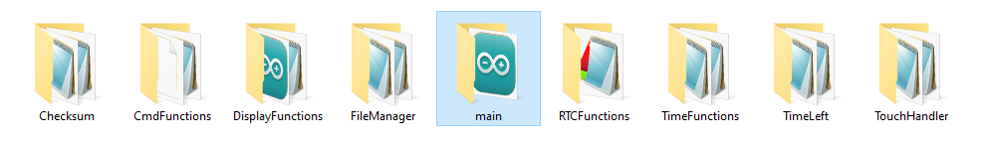

**Figure 3:** Motus Interface Board custom libraries

* Copy the "main" folder to the ‘C:\Users\<your-username>\Documents\Arduino\’ directory, and copy the remaining folders to the ‘C:\Users\<your-username>\Documents\Arduino\libraries’ directory. The "main" folder contains the primary sketch, while the other folders house the custom libraries required for the main sketch to function properly.
* Make sure the Arduino Giga is connected to the PC.
* Open the Arduino IDE.



**Figure 4:** Installing Required Arduino Libraries

* Ensure you select the correct port and confirm that "Arduino Giga R1" is visible as shown in Figure 4. Click on the Libraries tab, then search for and install each library one at a time. If a library is already installed, you'll see "Remove" instead of "Install." In that case, check if it's the latest version. If it's not up to date and you select the most recent version, then the "Remove" button will change to "Install". You can then proceed with the installation, otherwise move on to the next library.

These are all the libraries to install if not previously installed. Use these recommended keywords below to search for the libraries. Multiple related libraries may be displayed but ensure to pick the correct one. For the “Gigadisplay” keyword that queries multiple relevant libraries to be installed, the installations need to be done one at a time.

| Keywords recommendation | Libraries to Install |
| --- | --- |
| SD | * SD by Arduino, SparkFun |
| TinyGPS | * TinyGPSPlus by Mikal Hart |
| Scheduler | * Scheduler by Arduino |
| Gigadisplay | * Arduino_GigaDisplay by Arduino * Arduino_GigaDisplayTouch by Arduino * Arduino_GigaDisplay_GFX by Arduino |

If you have gotten to this point, you are done gathering all the relevant libraries to be uploaded to the Arduino Giga.

### 5.3.2 Uploading the Sketch and libraries to the Arduino Giga

Now it’s time to upload your sketch to the Arduino Giga. Ensure that the microcontroller is still connected to your PC and that you have it selected, as previously shown in Figure 4 above.

* Navigate to the ‘main.ino’ file located in the `C:\Users\<your-username>\Documents\Arduino\main` directory. This file should automatically open in the Arduino IDE.



**Figure 5:** Tools Menu

* Go to the Tools menu.
  + Verify that the correct port for the Arduino Giga R1 is selected.
  + Ensure that the correct board, Arduino Giga R1, is also selected.
  + Under Flash Split, select 2MB M7 + M4 in SDRAM.
  + Under Target Core, select Main Core.
* Then click on “Verify” to compile the sketch. Please be patient, this may take a few minutes. If you don’t get any errors when the compilation is complete, then your sketch is ready to be uploaded to the Arduino Giga.
* Click on Upload and wait for the sketch and libraries to be uploaded to the Arduino Giga. If there are no errors during upload, then the microcontroller has been successfully configured.

# 6.0 Hardware Setup And Wiring

This section will cover setting up and wiring the hardware components of the system. Some modules will need to be soldered first before stacking or wiring to other components and the step-by-step instructions will be broken into the different systems as follows.

* Interface Board System
* Sensorgnome System
* DCS System
* Power System

## 6.1 Interface Board System

This is the system that handles the data relay from the SensorGnome to the DCS for efficient communication. The major components for this system are the Arduino GIGA R1 WiFi, Arduino GIGA Display shield and the Adafruit Ultimate GPS Logger Shield with other Auxiliary components. The following sections below outline the process of assembling these components.

### 6.1.1 Soldering Header pins to the Adafruit Ultimate GPS Logger Shield and Installing microSD card

**Table items:**

* **Table 3, Item c3**
* **Table 3, item c4**
* **Table 3, Item c7**
* **Table 3, item c8**

Follow the instructions on the [Stacking Header Pin Guide](https://learn.adafruit.com/adafruit-ultimate-gps-logger-shield/shield-headers#assembly-with-stacking-headers-578959) to solder the Stackable Header Pins to the shield. Although the shield comes with male header pins, do not use them—instead, use the ones purchased separately for this purpose. Also the 2 x 3 Female Header Pins will be soldered to the board for SPI connection. Alternatively, you can carefully cut the stackable header pins into a pair of three pins to create a 2x3 header pin. Solder this at the opposite end to allow it to connect seamlessly to the male ISC pins of the Arduino Giga. Cut the stackable header to create a two-pin connector, then solder it to the TX and RX through-holes.



**Figure 6:** Soldering Pins

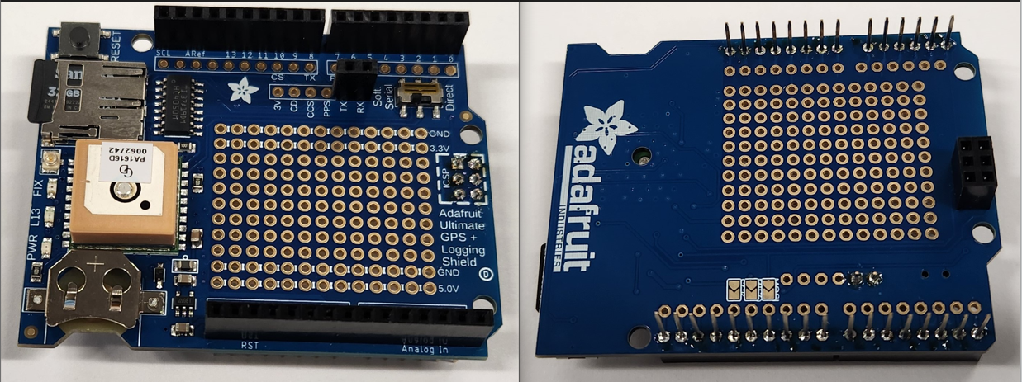

**Figure 7:** Top and bottom after soldering

After completing the soldering process, make sure the switch is on “Soft Serial” as shown in Figure 6, then create a text file named "config.txt”. In this file, input the GOES parameters for the DCS transmitter as shown in Figure 8. Currently, only Satlink and Microcom DCS transmitters are configured to operate with the Interface Board. Use 1 for the Satlink transmitter and 2 for the Microcom transmitter. Please note that this will overwrite previous configurations in the transmitter. Transfer the text file to the 16GB MicroSD card and install the card to the shield. A CMOS battery is not required but can be used if you desire to have the shield maintain a GPS fix while the Arduino Giga is not connected to power.

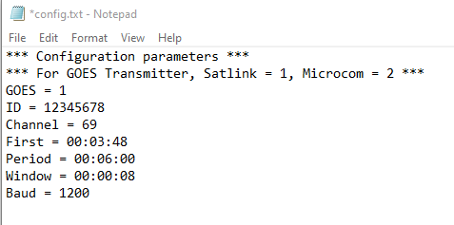

**Figure 8:** Example config.txt file with GOES parameters

### 6.1.2 Stacking the Adafruit Ultimate GPS Logger Shield on the Arduino GIGA R1 WiFi and wiring

**Table items:**

* **Table 3, Item c1**
* **Table 3, Item c3**
* **Table 3, Item c10**

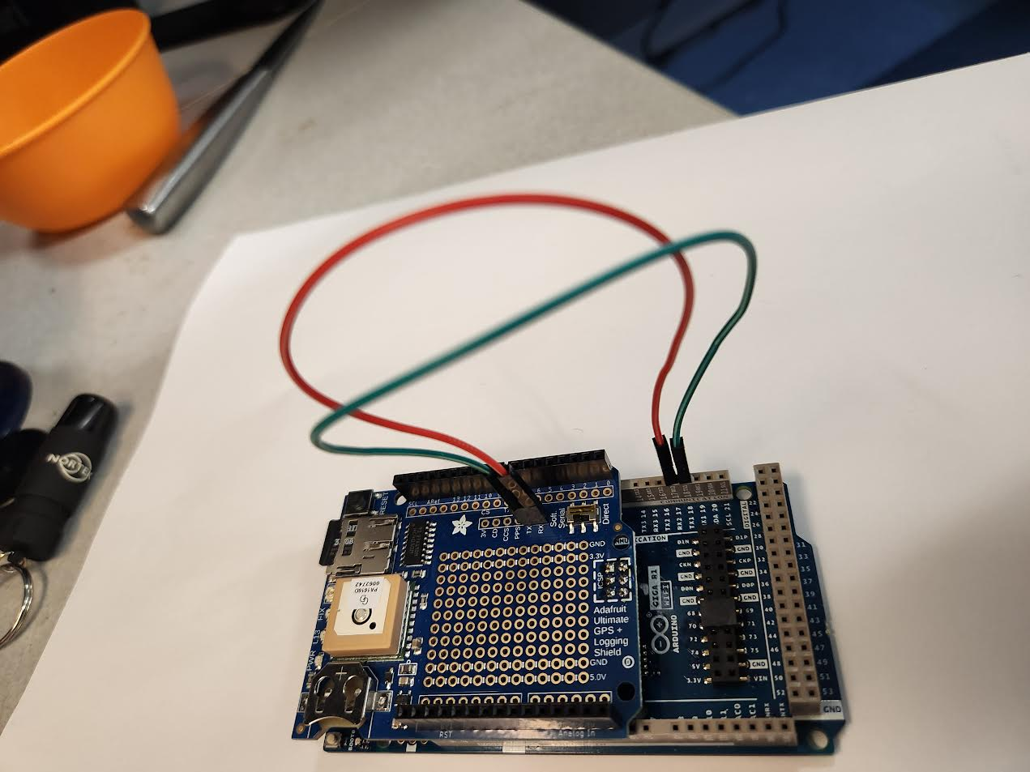

**Figure 9:** Adafruit Ultimate GPS Logger shield stacked on the Arduino GIGA R1 WiFi and wired to the UART port.

After the Adafruit Ultimate GPS Logger Shield soldering has been completed, follow the Pin labels to stack it on the Arduino GIGA. Also the SPI connection should align once it is properly placed. Be mindful of the SPI pins when doing this. Then wire both boards using the Male-Male Jumper Wires as documented below and shown in Figure 9.

**Arduino GIGA R1 WiFi Adafruit Ultimate GPS Logger Shield**

**TX ------------------------------- 19 RX1**

**RX ------------------------------ 18 TX1**



**Figure 9:** Adafruit Ultimate GPS Logger shield stacked on the Arduino GIGA R1 WiFi and wired to the UART port.

### 6.1.3 Stacking the Arduino GIGA Display Shield on the bottom of the Arduino GIGA R1 WiFi

**Table items:**

* **Table 3, Item c1**
* **Table 3, Item c2**

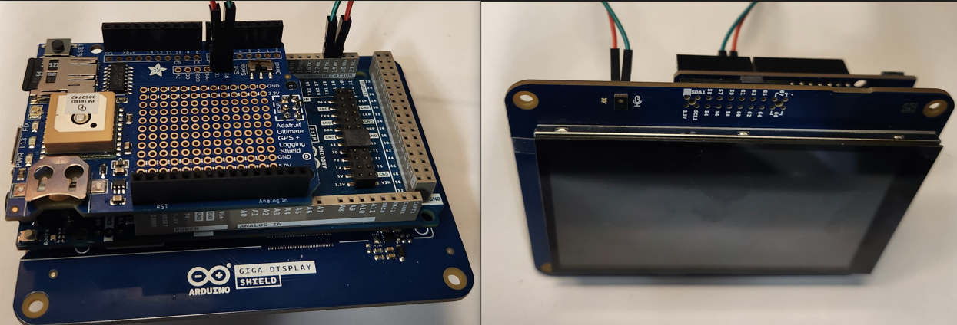

**Figure 10:** Arduino GIGA Display Shield stacked on the bottom of the Arduino GIGA R1 WiFi

The Arduino GIGA shield is mounted on the bottom of the GIGA R1 Wifi board as shown in Figure 10 above.6.1.4 Wiring RS232 to TTL converter and DB9 Breakout boards

**Table items:**

* **Table 3, Item c1**
* **Table 3, Item c5**
* **Table 3, Item c6**
* **Table 3, Item c10**

Solder the Male - Male jumper wires to the RS232 to TTL converter through-holes as shown in Figure 11 below.

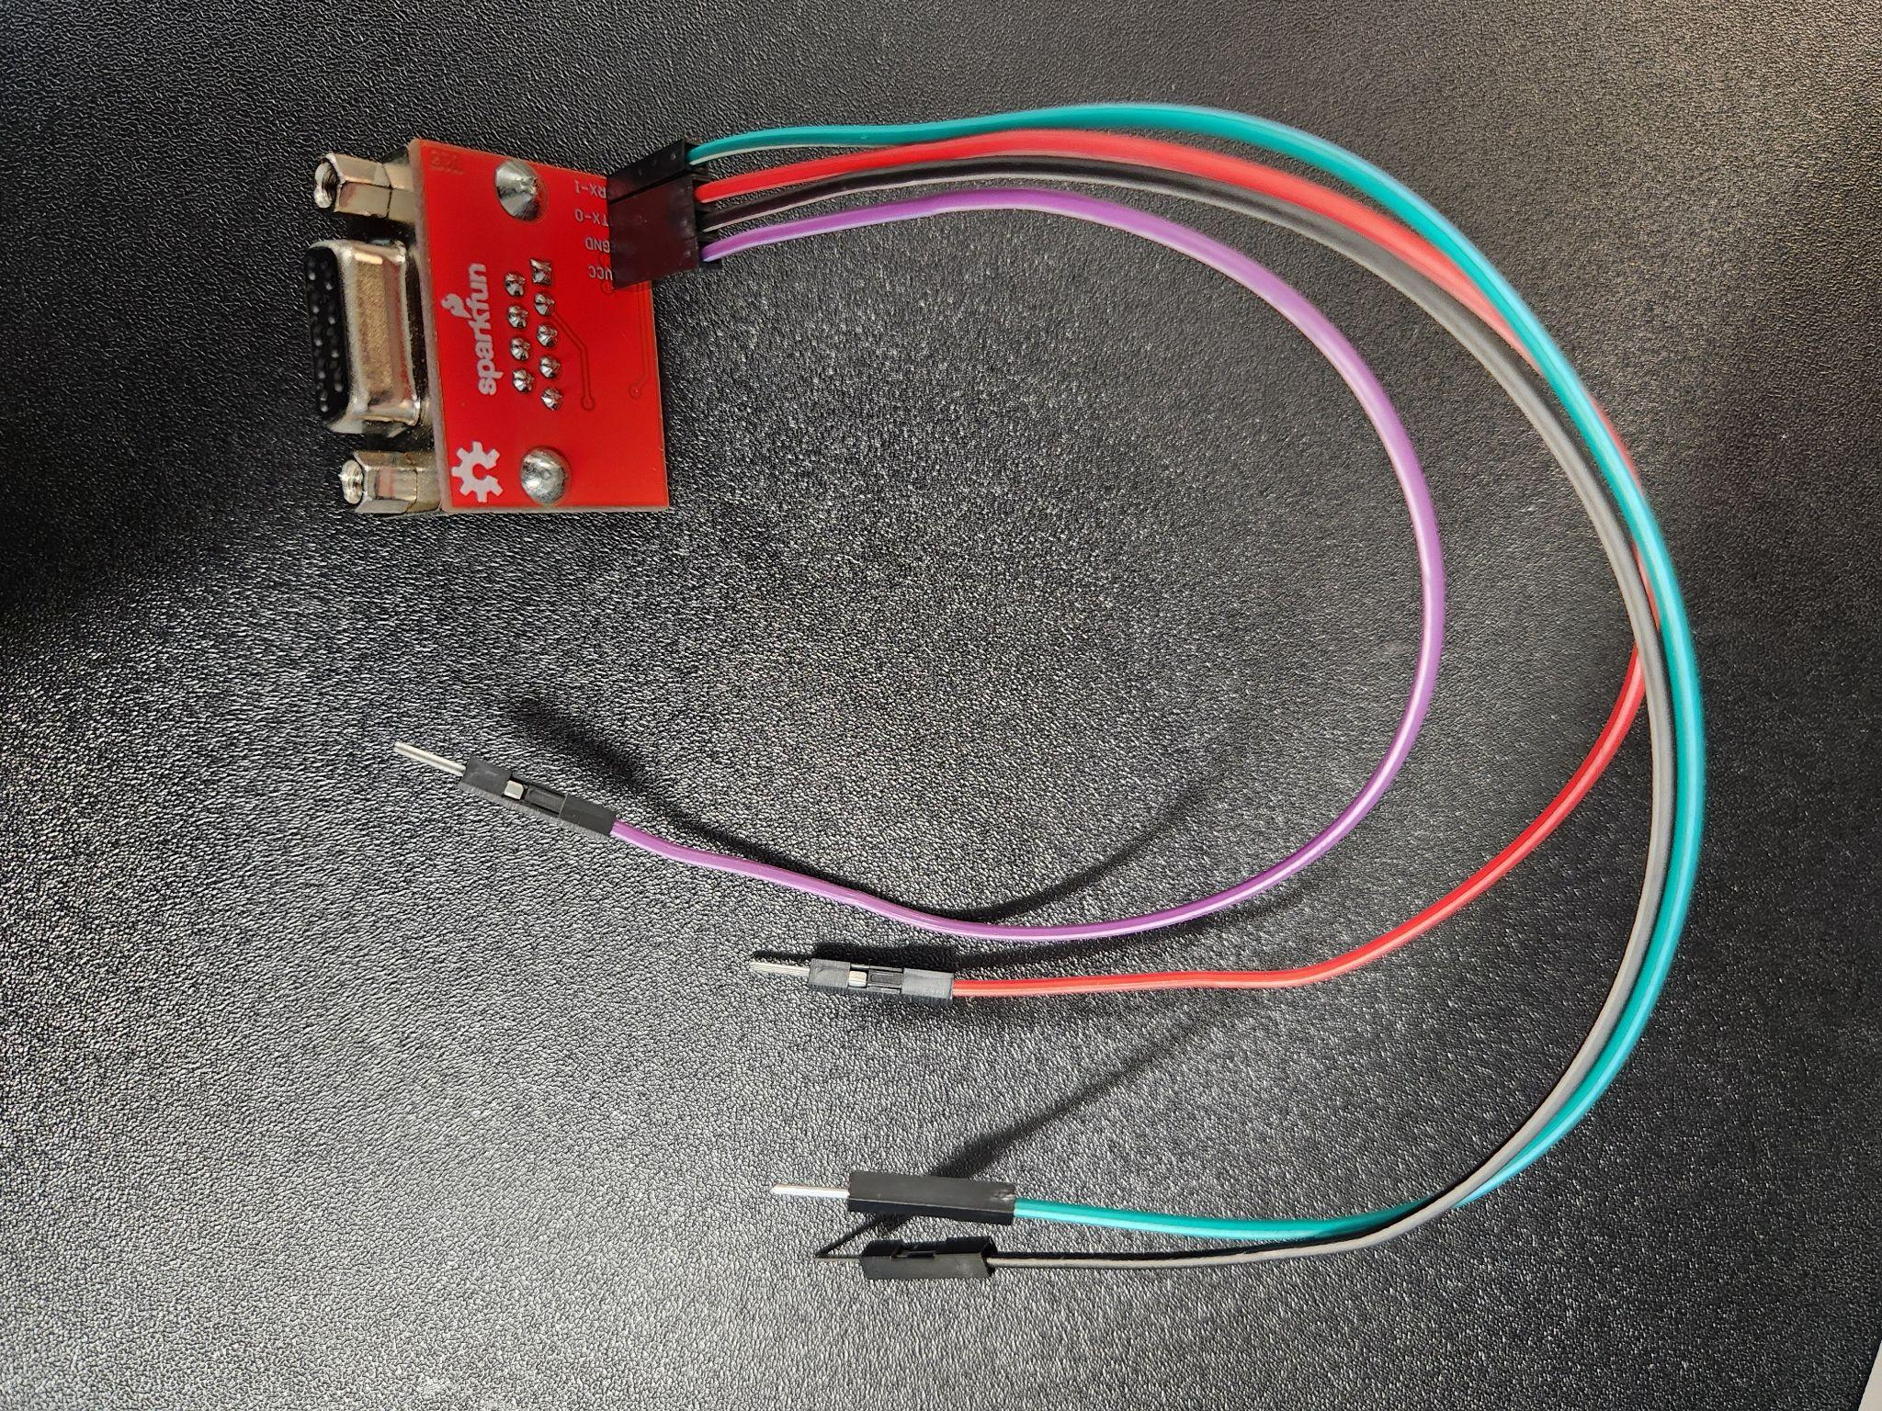

**Figure 11:** Male - Male Jumper Wires soldered to RS232 TTL Converter

Then wire the two DB9 Male Connectors at the following terminals.

**DB9 Male Connector 1 DB9 Male Connector 2**

**Pin 2---------------------------------------Pin 3**

**Pin 3---------------------------------------Pin 2**

**Pin 5---------------------------------------Pin 5**

If you are not using a Satlink transmitter, place a jumper between Pin 6 and Pin 7 on DB9 Male Connector 1 and connect Pin 4 to Arduino GIGA’s 5V pin as shown below, otherwise jump here.

**DB9 Male Connector 1 DB9 Male Connector 1**

**Pin 6---------------Jumper--------------Pin 7**

**DB9 Male Connector 1 Arduino GIGA R1 WiFi**

**Pin 4---------------------------------------5V**

Connect the other ends of the four wires soldered to the RS232 to TTL Converter to the Arduino GIGA as shown below.

**RS232 to TTL Converter Arduino GIGA R1 WiFi**

**RX-----------------------------------------16 TX2**

**TX-----------------------------------------17 RX2**

**GND---------------------------------------GND**

**VCC---------------------------------------3.3V**

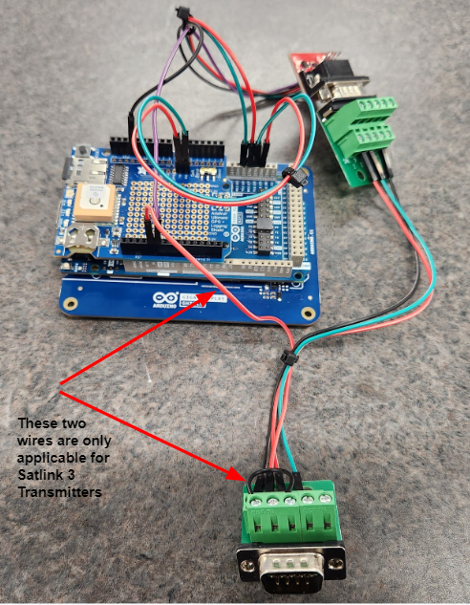

**Figure 12:** Interface Board

## 6.2 SensorGnome System

For information about Sensorgnome, visit [What is a SensorGnome?](https://docs.motus.org/sensorgnome#what-is-a-sensorgnome). The major components are the Adafruit Feather 32u4 and Raspberry Pi 4 B 8GB with other Auxiliary components. The following sections below outline the process of assembling these components.

### 6.2.1 Setting up the Adafruit Feather 32u4 and connecting to the Raspberry Pi 4.

**Table items:**

* **Table 1, Item a1**
* **Table 1, Item a2**
* **Table 2, Item b1**
* **Table 2, Item b2**
* **Table 2, Item b3**
* **Table 2, Item b4**
* **Table 2, Item b5**
* **Table 2, Item b6**
* **Table 2, Item b7**

Follow the Instructions in the [link](https://docs.motus.org/sensorgnome/appendix/ctt-dongle) shared earlier if you haven’t already done so on setting up the Adafruit Feather 32u4, then connect it to the OmniDirectional Antenna and Raspberry Pi 4 as shown in the Figure 13 below.

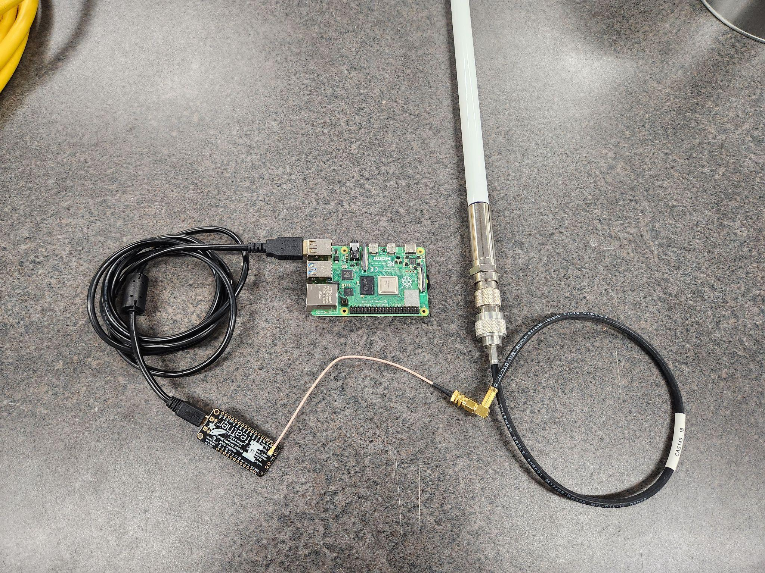

**Figure 13:** SensorGnome system

Note: Some parts used in this image are for demonstration only and may not correspond with the actual part recommended for this build.

## 6.3 DCS Transmitter System

**Table items:**

* **Table 4, Item d1**
* **Table 4, Item d2**
* **Table 4, Item d3**
* **Table 4, Item d4**

Connect the GPS Antenna to the DCS Transmitter. Also connect the DCS transmitter’s Antenna to the DCS Transmitter using the GOES Cable as shown in Figure 14 below. Note that different DCS Transmitters may have different types of terminals for these connections.

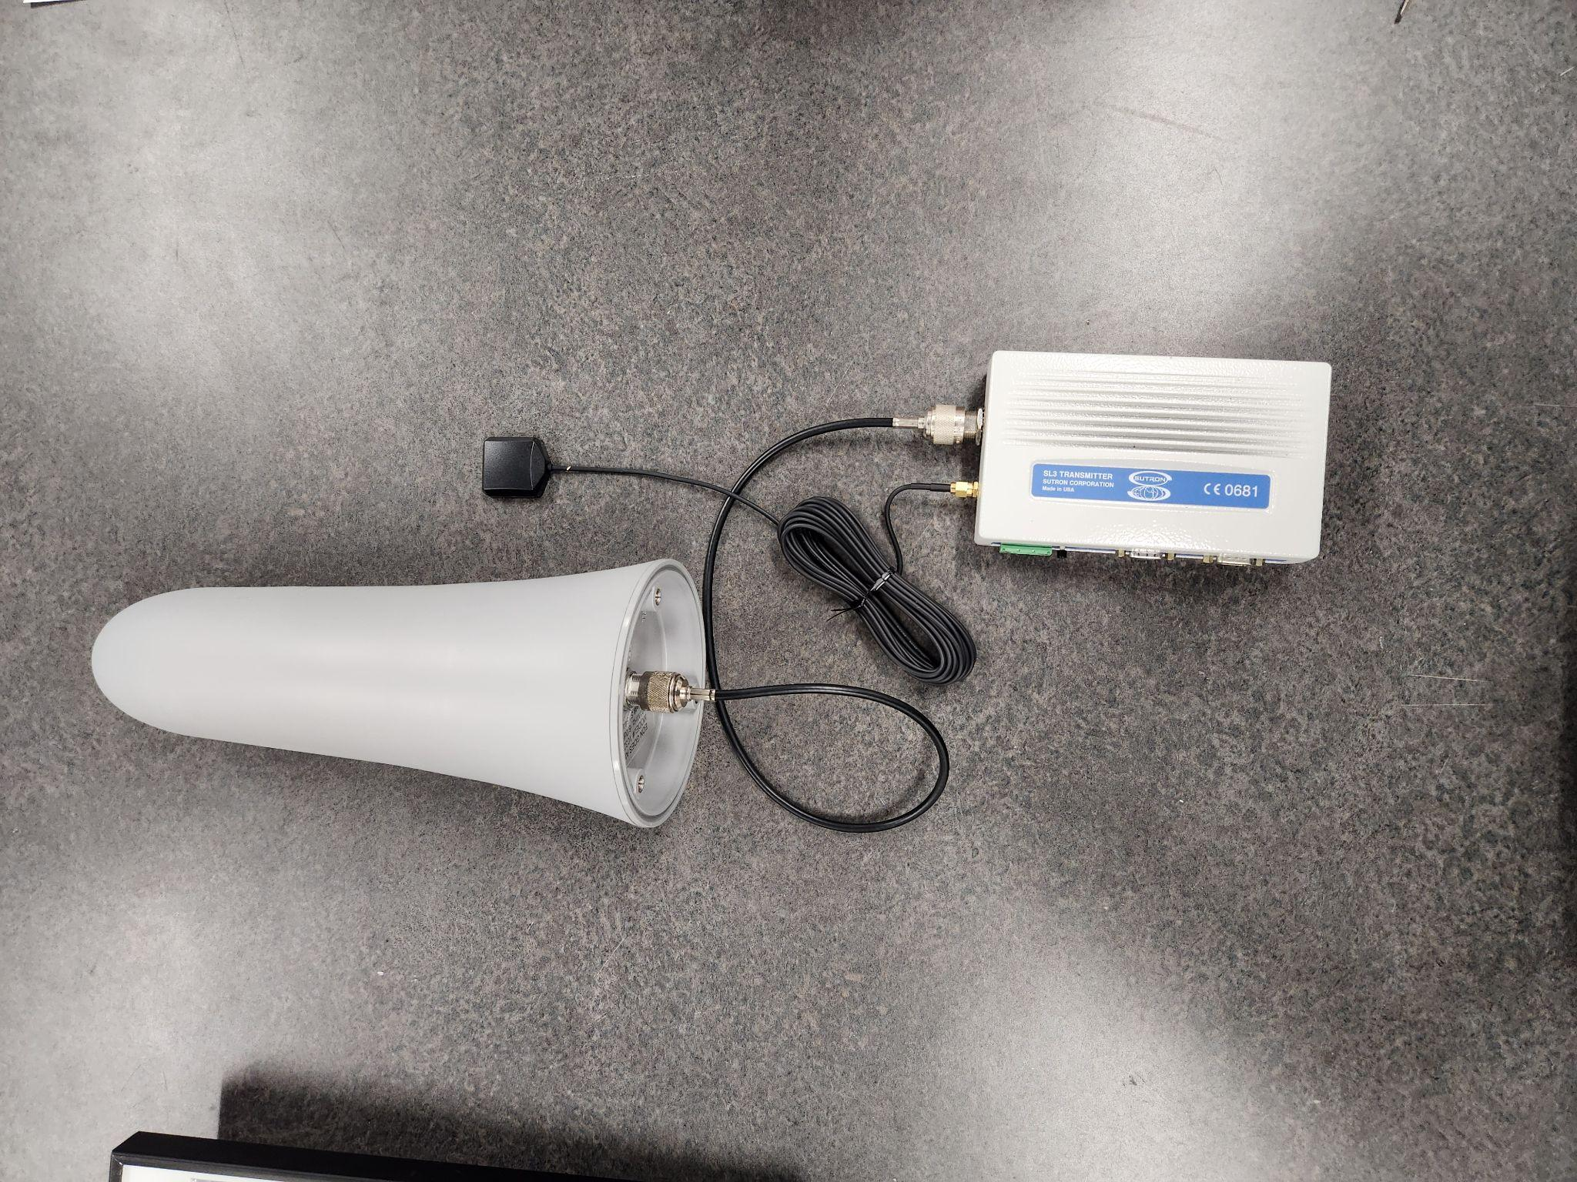

**Figure 14:** DCS System

Note: Some parts used in this image are for demonstration only and may not correspond with the actual part recommended for this build.

## 6.4 Power System

**Table items:**

* **Table 5, Item e1**
* **Table 5, Item e2**
* **Table 5, Item e3**

Connect the Battery and Solar panel to the Voltage Regulator as shown in Figure 15 below.

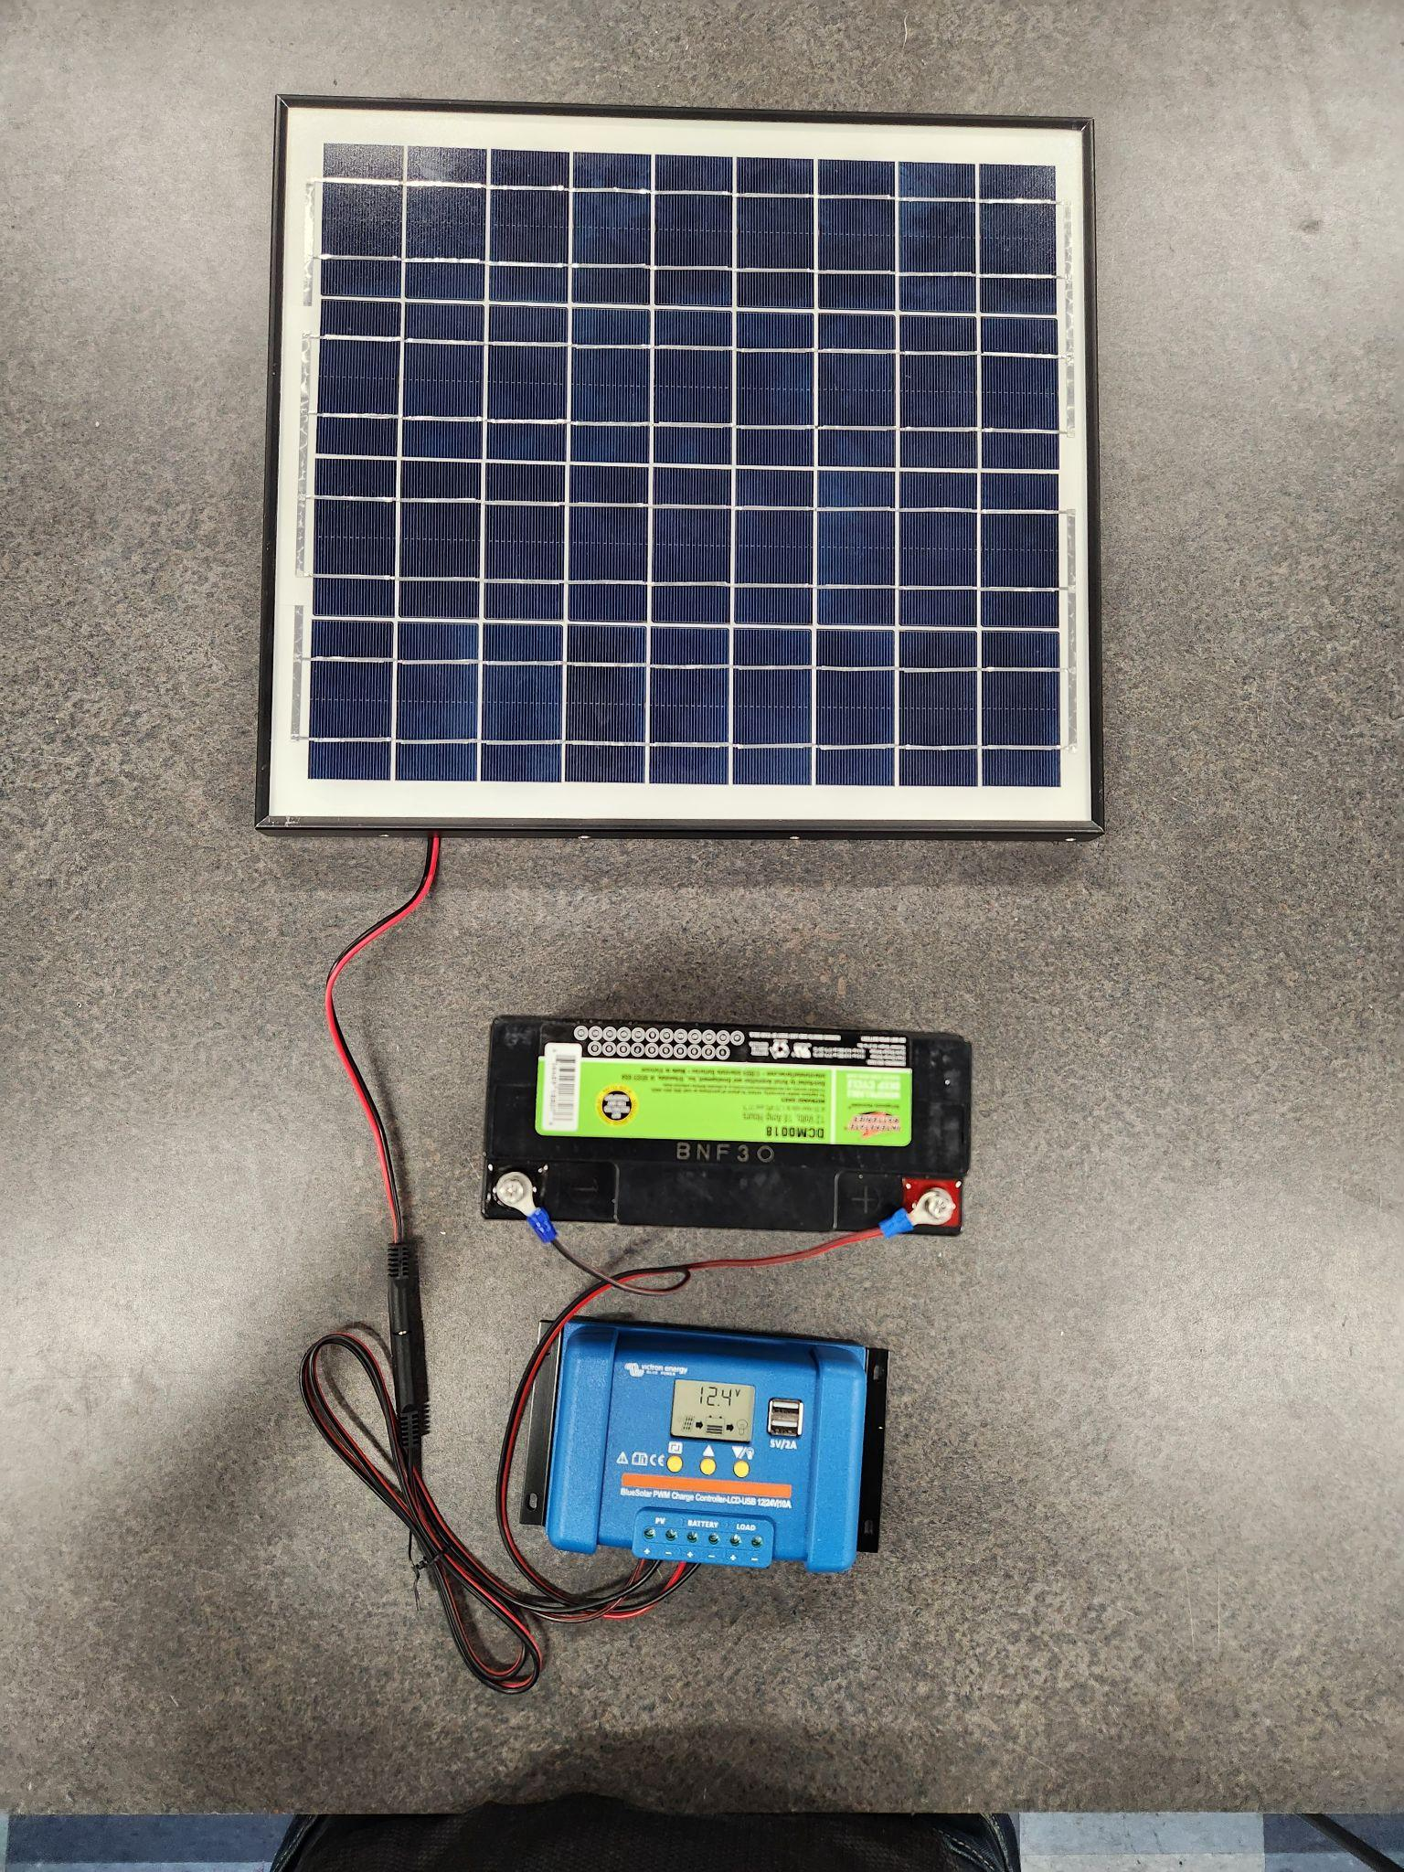

**Figure 15:** Power System

# 7.0 Motus - DCS system

**Required Items:**

Now that all these individual subsystems have been put together, let’s go ahead and connect everything together to make one Motus-DCS system. The wiring is as follows.

**Arduino GIGA (USB-C end)----------------****A3****----------------Voltage Regulator(USB-A end)**

**Raspberry Pi 4 (USB-C end)----------------****C12****--------------Voltage Regulator(USB-A end)**

**DCS Transmitter(GND)-----------------------------------------Voltage Regulator(LOAD -)**

**DCS Transmitter(VDC)-----------------------------------------Voltage Regulator(LOAD +)**

**Arduino GIGA (TX3)--------------------****C11****------------------Raspberry Pi 4 (Pin 10, GPIO15, RX)**

**Arduino GIGA (RX3)--------------------****C11****------------------Raspberry Pi 4 (Pin 8, GPIO14, TX)**

**Arduino GIGA (GND)-------------------****C11****------------------Raspberry Pi 4 (Pin 6, GND)**

Figure 16 below shows an image of a complete system.

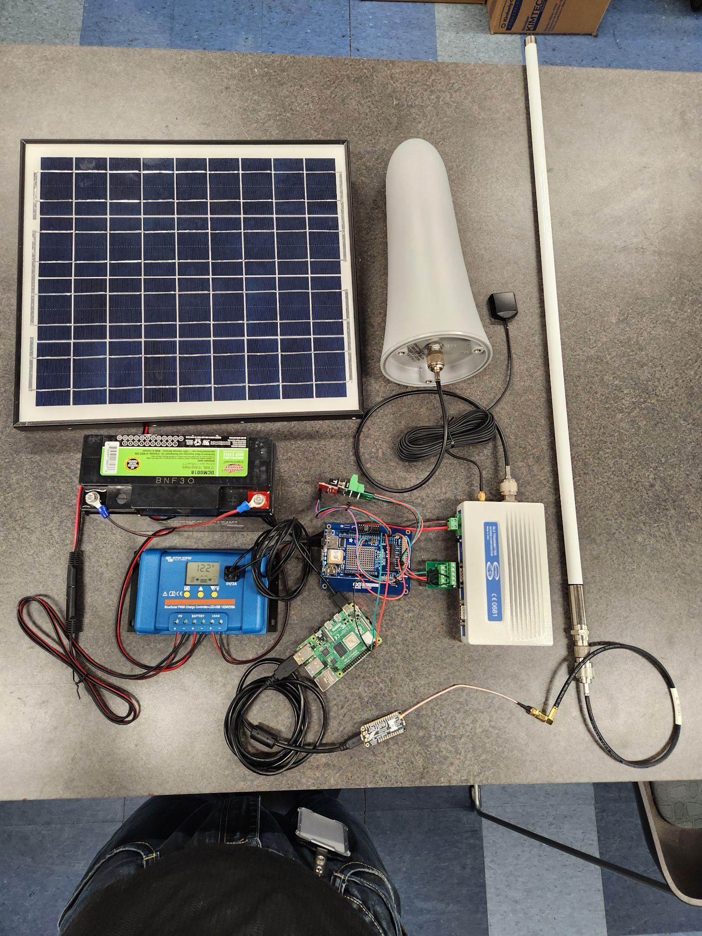

**Figure 16:** Motus-DCS System

Note: Some parts used in this image are for demonstration only and may not correspond with the actual part recommended for purchase.

# 8.0 Starting up the DCS - Motus system

Once everything is connected and powered on, the Interface Board goes through a series of checks during initialization. The background will be yellow during each check, red if a check fails, and green if the check is successful. If the background turns red, disconnect the Interface Board’s USB cable, follow the recommended steps to resolve the issue, and then reconnect the USB cable.

It's important to note that the Interface Board will first attempt to set the time using the DCS transmitter’s clock for up to five minutes with a yellow background. If the transmitter’s GPS hasn't synced within that time, the Interface Board will switch to using its own GPS, displaying a counter in seconds, with a yellow background to indicate how long the process is taking. The system won't proceed beyond this stage without a GPS fix. If you wait too long, you may want to disconnect and reconnect the Interface Board’s USB cable, leaving the DCS transmitter powered on, as the transmitter's GPS may have obtained a fix at that time.

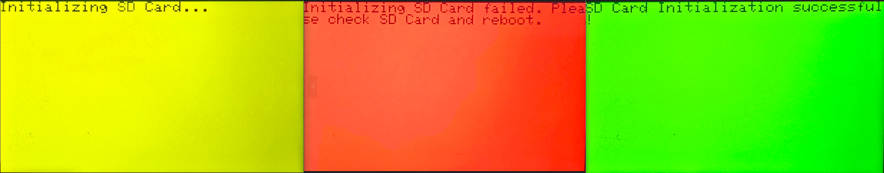

Checking When SD Card Initialization fails When SD Card Initialization is successful

**Figure 17:** Example of SD card check

Also, once the GOES parameters from the ‘config.txt’ file have been used to configure the DCS transmitter, the settings confirmation will display for fifteen seconds (white background) to confirm the configuration parameters.

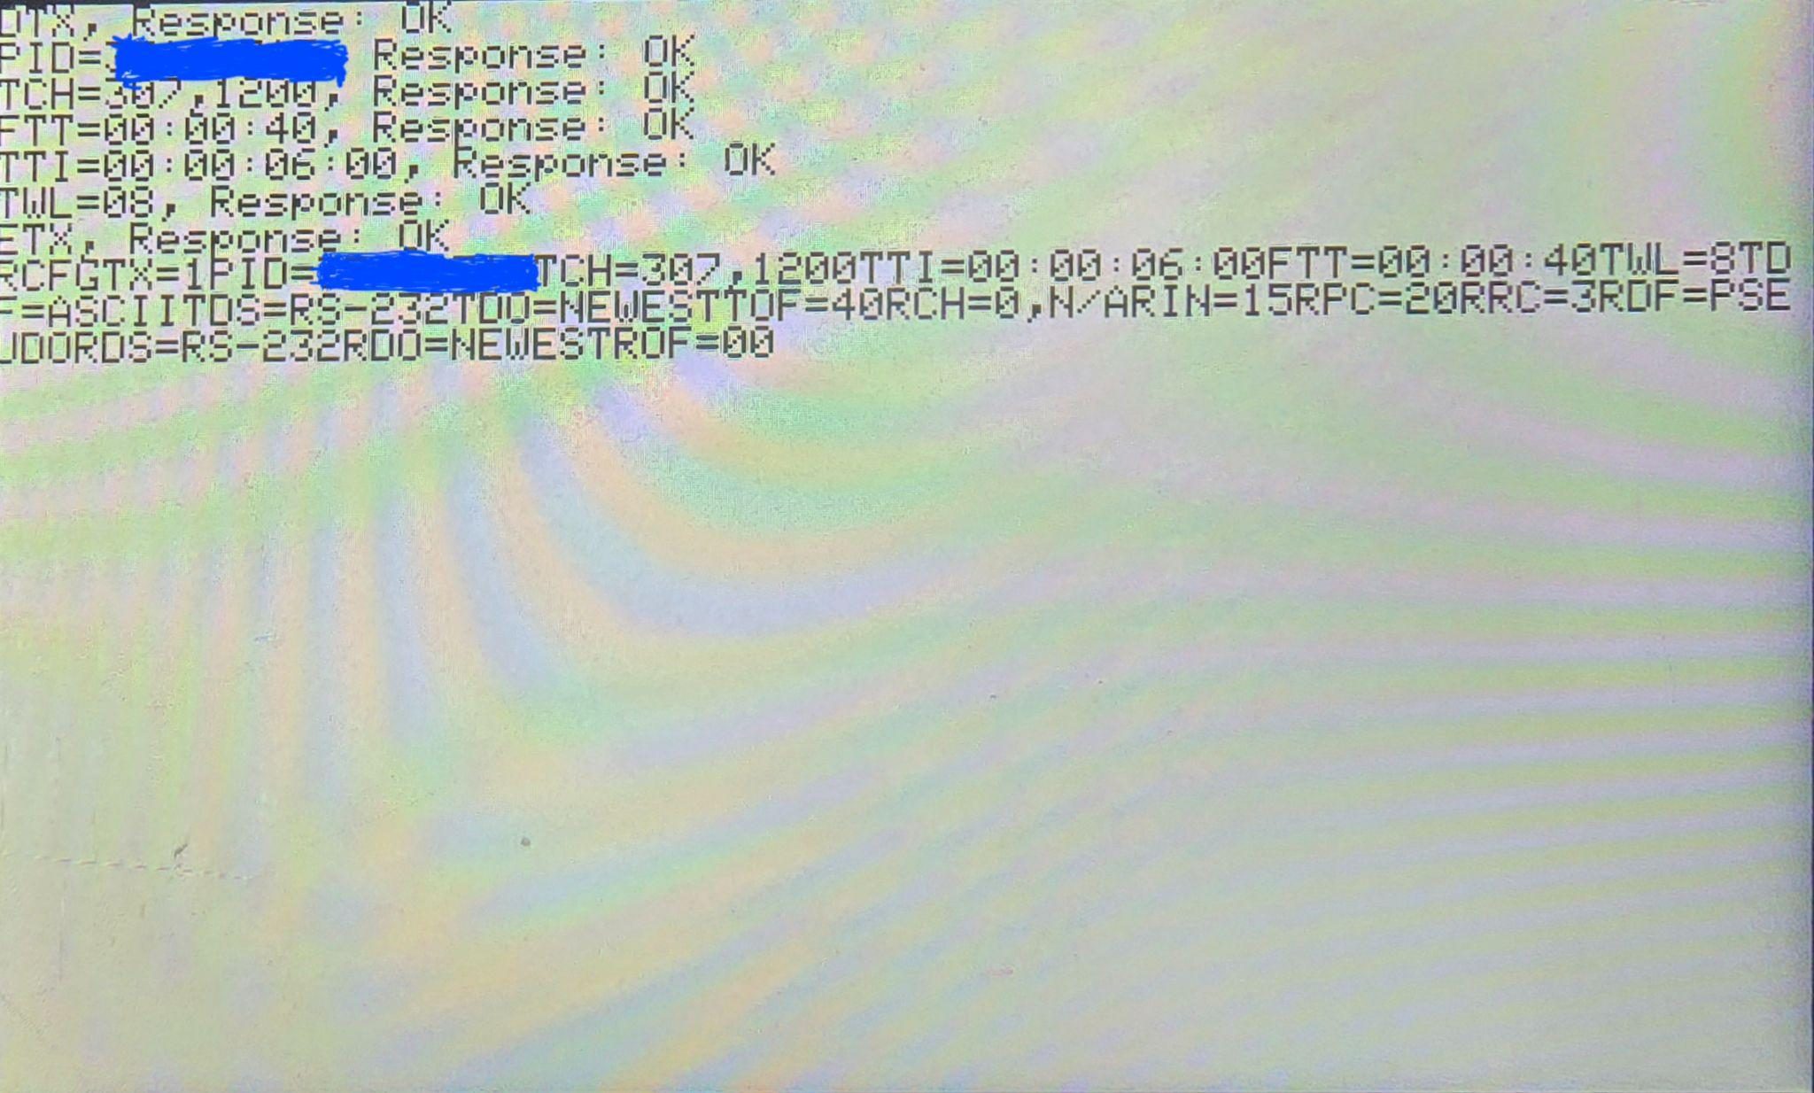

**Figure 18:** DCS Transmitter Settings confirmation. Format may differ depending on the transmitter.

Upon successful initialization, the date and time in UTC will be displayed on the display shield, with a reboot button positioned in the bottom right corner. The LED will turn off after two minutes of inactivity, and touching the screen will turn it back on. Holding the reboot button for two seconds will restart the Interface Board. When a tag is detected, it will be shown on the screen with a yellow background; however, tag detection will not wake the screen—it will only respond to touch.

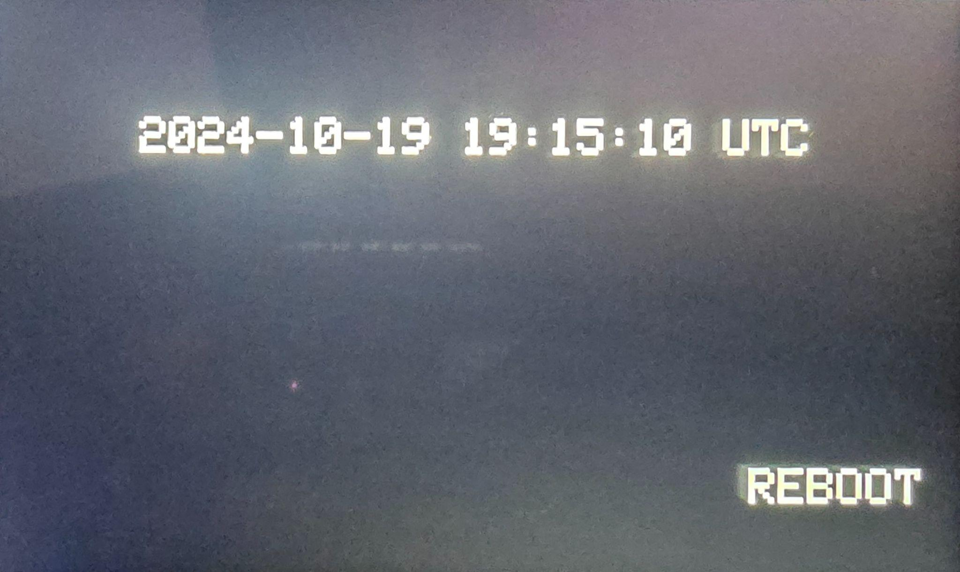

**Figure 19:** Display after successful initialization

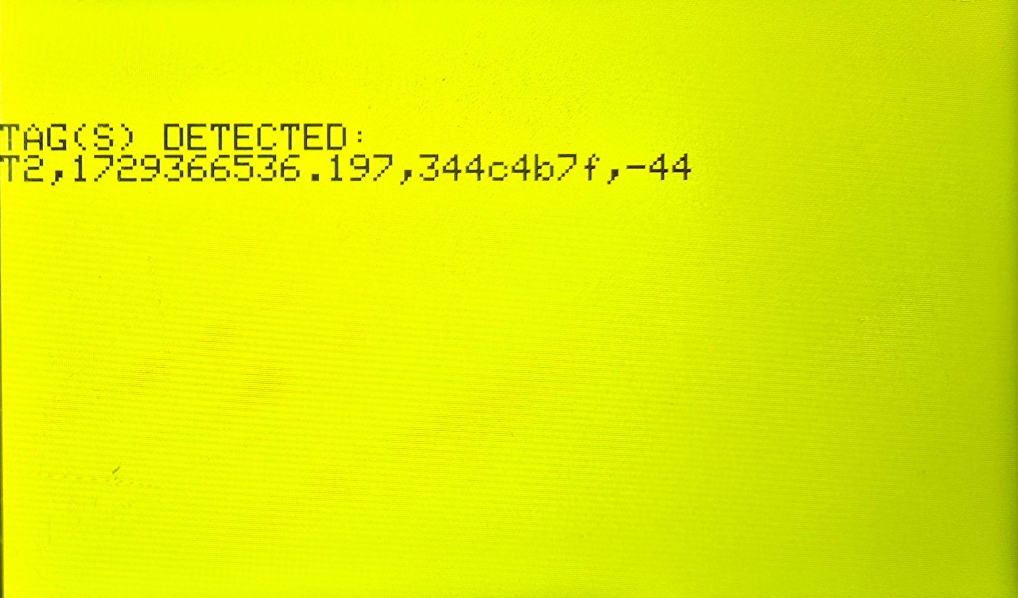

**Figure 20:** Display when tags are detected

## 8.1 Initialization Checks Sequence and Displays messages

* Initializing SD Card: Initializing SD Card
  + If Pass: SD Card Initialization successful!
  + If Fail: Initializing SD Card failed Please check SD Card and reboot
* Reading ‘config.txt’ file from SD Card: Reading config.txt file
  + If Pass: config.txt file read successful!
  + If Fail: config.txt file read failed Please check file and try again
* Configuring DCS Transmitter: Configuring DCS transmitter
  + If Pass: Communication with DCS transmitter failed. Please check connection and reboot
  + If Fail: Please check if the GOES ID in the config.txt file is correct and reboot
* Displays transmitter setup confirmation
* Setting RTC using DCS Transmitter: Setting RTC using transmitter
  + If Pass: Setting RTC with transmitter successful!
  + If Fail: Setting RTC with transmitter failed after five minutes, setting RTC using GPS
    - Setting RTC using GPS: Trying to set RTC using GPS + (time in seconds)
    - If Pass: RTC was successfully set using GPS!
* Creating file to save tags: Initializing file manager and creating file
  + If Fail: File creation unsuccessful Please ensure the SD card is OK and reboot
* Checks complete: SYSTEM INITIALIZATION SUCCESSFUL!!!

# 9.0 Motus-DCS custom libraries and the functions

This section describes what each Motus-DCS library does. Some of these libraries may be applied to other DCS applications for data management and DCS transmissions.

## 9.1 File Manager

The FileManager library manages SD card operations for logging data, configuration settings, and archiving messages. The attributes and methods are described below.

### 9.1.1 FileManager Attributes

* **_chipSelect:** This integer attribute holds the pin number used to select the SD card. It’s essential for initiating communication with the SD card via SPI.
* **_directoryPath:** A String that stores the directory path formatted as ‘/RCVDMSGS/YYMMDD’, where files will be created. This helps keep data organized by date.
* **_currentFileName:** A String that stores the name of the current file in use. This is updated each time a new file is created and helps direct read and write operations to the correct file.
* **_dataFile:** An instance of the File class, representing the file currently open for reading or writing. This is used to access SD card data efficiently.
* **_currentFilePos:** Tracks the current position within the file during read operations. It allows for resuming reads from where the last read left off.
* **_charsWritten:** Tracks the total number of characters written to the current file, aiding in file size management and monitoring.
* **_charsRead:** Tracks the number of characters read from the file so far. This, along with _charsWritten, is used by getRemaining() to calculate unread data.

### 9.1.2 FileManager Methods

* **initialize:** Initiates communication with the SD card, making it ready for read and write operations.
* **createNewFile:** Creates a new file with a unique name in the ‘SD /RCVDMSGS/YYMMDD’ directory, preventing overwriting and ensuring organized data storage based on the date.
* **writeLine:** Appends a line of data to the current file, updating _charsWritten to track the total characters written to the file.

* **readUpTo:** Reads a specified number of characters from the current file, beginning from _currentFilePos, and updates _charsRead.
* **readConfig:** Loads configuration settings from config.txt, filling the Config structure. The config structure is the custom data structure that retains the GOES parameters.
* **writeToFile:** Archives messages into either ‘SD/TXARCH/YYMMDD/SENT.TXT’ or ‘SD/TXARCH/YYMMDD/UNST.TXT’, depending on the sentStatus, providing organized storage for message logs. The sentStatus is a boolean that indicates if the DCS transmitter responded that the GOES message was received.

* **getFileSize:** Returns the current file’s size, helping monitor storage capacity and manage data usage.
* **getRemaining:** Calculates the difference between _charsWritten and _charsRead, indicating the number of unread characters in the file.

## 9.2 CmdFunctions

This file contains functions primarily for handling communications with the DCS Transmitter.

* **sendSL3Get:** Sends a command over Serial3 to a Satlink transmitter with the specified `input`, waits briefly, and reads the response after cleaning up extra characters like `>`, `\n`, `\r`, and special control characters. This is primarily used to request for the time and date from the Satlink transmitter.
* **sendSL3Set:** Similar to `sendSL3Get`, this function sends a command but expects a response indicating the result of a "set" operation. It also cleans and formats the response string. This is primarily used to configure the Satlink transmitter.
* **sendSL3Tx:** Initializes a buffer on Serial3 and then sends a command, handling the command in two parts: preparing the buffer with ‘EXTBUF INSERT’ and then sending the actual command with a delay to allow Serial3 to respond. This is used to send buffer messages to the Satlink transmitter for transmission.
* **mComGet:** This function retrieves a command's value from a Microcom transmitter via Serial3 by sending the request command, then cleaning up and parsing the response to extract the value after the `=` character, truncating any decimals. This is primarily used to request for time and date from the Microcom transmitter.
* **mComSet:** Sends a set command to Microcom transmitter via Serial3, formats the response by checking for "OK" or "ERR," and attaches a status message to the response.
* **myCommands:** Takes a ‘Config’ structure as input and builds a list of commands based on `GOES` parameter values (case 1 for Satlink and case for 2 Microcom), using other helper functions (`sendSL3Set` and `mComSet`) to construct commands based on the structure fields.
* **TXCommands:** Handles transmission commands based on ‘cmdType’. cmdType indicates if the command is meant for a Satlink transmitter or Microcom transmitter.

## 9.3 TimeFunctions

This module is capable of returning accurate date and time from Satlink 3 Transmitter, Microcom Transmitter and GPS module in a data structure named ‘timeStruc’ with fields for `year`, `month`, `day`, `hour`, `minute`, `second`, and `validTime` (a boolean flag indicating if the time data returned is valid).

* **SL3Time:** Sends a "!TIME" request to the Satlink 3 transmitter. Parses the response string (expected format: `"YYYY/MM/DD hh:mm:ss"`) to populate ‘year’, ‘month`, `day`, `hour`, `minute`, and `second` fields in `timeStruc`. Sets `validTime` to true if parsing is successful and false otherwise.
* **mComTime:** Retrieves date and time separately via `mComGet("DAT?")` and `mComGet("TIM?")`, then combines them. Parses the combined string (expected format: `"MM/DD/YYYY hh:mm:ss"`) and assigns values to `year`, `month`, `day`, `hour`, `minute`, and `second` in `timeStruc`. Sets `validTime` to true if parsing is successful and false otherwise.
* **GPSTime:** Uses the `TinyGPSPlus` library to read data from GPS via `Serial2`, timing out after a set period (currently set to 3 seconds). Once GPS data is valid, it populates the `timeStruc` fields with `year`, `month`, `day`, `hour`, `minute`, and `second`. Sets `validTime` to true once the data changes, indicating the GPS date and time just updated.

## 9.4 RTCFunctions

This module provides functions to set the Real-Time Clock (RTC) built into the Arduino GIGA from sources like Satlink 3 Transmitter, Microcom transmitter and GPS. Accurate time can subsequently be retrieved from the RTC. It interacts with the `timeStruc` structure from `TimeFunctions.h` to manage and format time data.

* **RTCSet:** Sets the RTC based on a specified time source, where 1 corresponds to SL3Time, 2 to mComTime, and 9 to GPSTime. After retrieving the time data, it checks if the data is valid, then converts it into the tm format and sets the RTC using set_time. The function returns true if the operation is successful, false otherwise.
* **RTCTimeString:**  Retrieves the current RTC time and formats it as a readable string in the format "YYYY-MM-DD hh:mm:ss." This formatted string is useful for display or logging purposes.
* **RTCTimeStruc:** Retrieves the current RTC time and converts it into a ‘timeStruc’ structure. Each field (year, month, day, hour, minute, second) is populated, and validTime is set to true. This function is helpful for cases where structured time data is preferred.
* **RTCTimeFile:** Retrieves the current RTC date and formats it as a compact string in the format "YYMMDD," making it ideal for use in filenames.

These functions provide an efficient way to set and retrieve time data from the RTC, supporting various needs such as display, structured data access, and organized file naming.

## 9.5 TimeLeft

This module uses the GOES parameters to calculate the number of characters it can transmit and how many seconds left to T - 3 minutes, where T is the next transmission time. This is the case because 3 minutes prior to transmission, the Interface Board sends the messages to the transmitter’s buffer.

* **totalSeconds:** Converts a formatted time string (formatted as "HH:MM:SS") into the total number of seconds. It parses hours, minutes, and seconds separately from the input string, then calculates the cumulative seconds. This function provides a straightforward way to convert time representations for easier arithmetic operations.
* **timeLeft:** Calculates the remaining time in seconds until the next period, based on the `first` scheduled time, `period` interval, and the current time represented by the `timeStruc` structure. It converts the `first` and `period` times to total seconds, adjusts the `first` time to account for a 3-minute (180-second) offset, and then calculates the remaining time by comparing the current time in seconds to the period interval.
* **numberOfChar:** Calculates the approximate number of bytes that can be transmitted within a specified transmission `window` at a given `baudRate`. It converts the `window` time into seconds, then calculates the total number of bytes using the baud rate, and applies a linear equation 0.872x - 76 to account for travel time of the GOES message and stats that will be appended to the message like battery voltage. Leaving the designated transmission bytes at 100% will most likely step on another DCS transmitter’s window.

## 9.6 DisplayFunctions

This module initializes the display on the GIGA Display Shield, sets up colors, and provides functions to render text and animated graphics on the screen.

* **initDisplay:** Initializes the display by calling `display.begin()` to prepare it for rendering graphics and text.
* **initShow:** Displays an introductory animation using rounded rectangles. The center of the display is calculated based on the screen dimensions (`cx`, `cy`), and a loop iterates to draw progressively larger rectangles. Each iteration of the loop is delayed to create a 5 second duration effect, gradually building up the animation. After the animation, `displayText` is called multiple times to show the message "MOTUS WILDLIFE TRACKING SYSTEM DCS TRANSMITTER INTERFACE BOARD" in alternating colors, creating a flashing effect.
* **displayText:** Fills the screen with a specified background color, then sets the text size, color, and position using `setCursor`. Prints the provided text string in the chosen color, allowing for customization of color, size, and placement.

## 9.7 TouchHandler

This module handles touch input detection on a display, using a touch detector object to capture and store the coordinates of the most recent touch.

* **initTouch:** Initializes the touch detector by calling touchDetector.begin() and sets up a handler function for when a touch is detected.
* **getTouchPoint():** Retrieves the coordinates of the last detected touch point, returns the value and then resets lastTouch to {-1, -1} to prevent repeated readings of the same touch point.

## 9.8 Checksum

The checksum file currently includes a preliminary validation function designed to ensure that incoming data from the Sensorgnome to the Interface Board adheres to expected formatting standards. While a full checksum implementation for verifying data integrity has yet to be developed, this initial check serves to confirm basic criteria based on the anticipated [data formats](https://community.motus.org/t/sensorgnome-v2-serial-output-feed/789#default-format-3) that the Sensorgnome will transmit.

Specifically, the function checks that:

* The first character is a valid identifier
* A comma appears in a specified position
* Only ASCII characters are present in the data

This provisional validation helps safeguard against improperly formatted data during transmission. Once the complete checksum functionality is implemented, this file will be updated to perform a robust integrity check on all incoming data.

# 10.0 GOES DCS Data

Data transmitted via the GOES Satellite system can be retrieved via several methods with the most common path being via the internet. GOES data can also be retrieved directly from the satellite system but requires separate infrastructure that is not discussed in this document. For more information regarding GOES retrieval directly from the satellite system via High Rate Information Transfer (HRIT) or Direct Readout Ground Station (DRGS), please reference the GOES information page found here: <https://noaasis.noaa.gov/GOES/GOES_DCS/goes_dcs.html>

To access GOES data users will need to establish a DADDS or Wallops user account.

Link to create a DADDS Account: <https://dcs1.noaa.gov/>

Click the Submit an Application for a GOES DCS SUA link and select Field Test Only User Account. Once the account has been established you can login to the DADDS portal to directly view and download GOES data. If you already have an established Service Use Agreement (SUA) and assigned Platform IDs you can also update the GOES Plat ID information, including platform description tables (PDTs), via the portal.

To establish a local readout ground station (LRGS) account contact a Wallops DCS Operator: 757-824-7450

Make sure to have the following information available: Name, Email Address, Organization, Telephone Number, Preferred 6-character username

Once your account has been created you can use your login credential to access any of the seven (7) public LRGS systems located on the following web page: <https://dcs1.noaa.gov/lrgs/LrgsSummaryStatus.html>

Data acquisition from LRGS systems is typically done using open source software like OpenDCS which is available on Github: <https://github.com/opendcs/opendcs>

The Github also has instructions and “how to” documentation for installing and configuring the OpenDCS software that can be found here: <https://opendcs-env.readthedocs.io/en/latest/index.html>

There are other free software tools available for GOES data retrieval as well as paid support options through various vendors that are not discussed here. For more information please reach out to the